#**Python program to show the concept of inheritance**

class Wolf:

price=500

def __init__(self,name,color):

self.name=name

self.color=color

def bark(self):

print("Grr.........")

class Dog(Wolf):

def bark1(self):

print("Woof Woof")

if __name__=="__main__":

pet1=Dog("Tommy","brown")

pet1.bark()

pet1.bark1()

print(pet1.name,"is of color",pet1.color)

**OUTPUT**

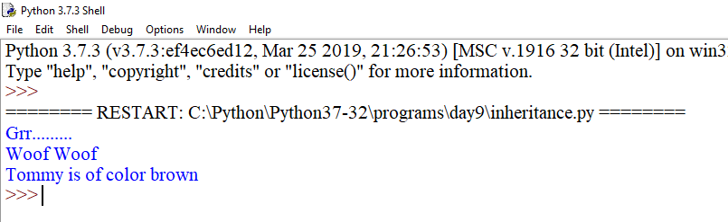

class Animal:

def __init__(self,name,color):

self.name=name

self.color=color

class Cat(Animal):

def mew(self):

print("Meow Meow")

class Dog(Animal):

def bark(self):

print("Woof Woof")

if __name__=="__main__":

#pet1=Dog("Tommy","Brown")

pet2=Cat("Lucy","White")

#pet1.bark()

pet2.mew()

#print(pet1.name)

print(pet2.name)

**OUTPUT**

